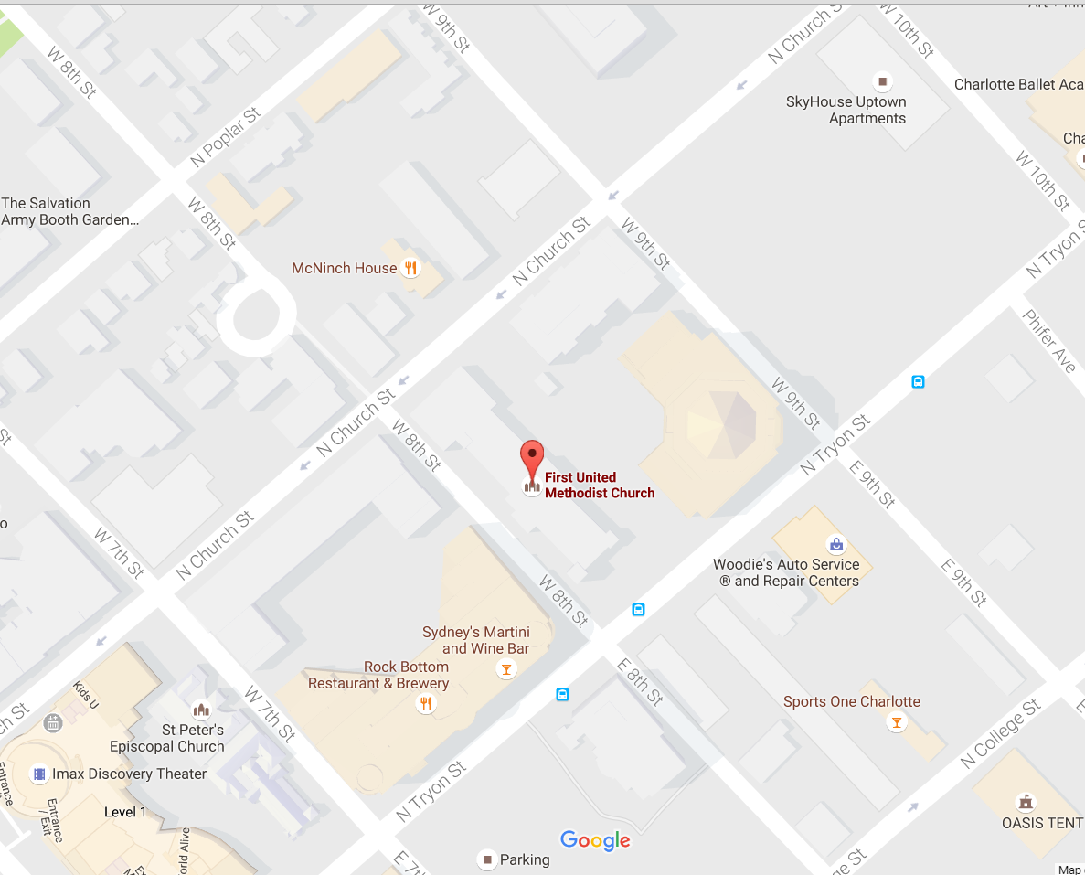
9th St. Parking deck: 163 W 9th St. in google maps. Sign overhead as you enter lot should say 525 N Tryon, First United Methodist Church

The Exceptional Foundation of Charlotte
Located in: First United Methodist Church
501 North Tryon Street
Charlotte, NC 28202

Using the church address in your gps is not helpful as it does not take you to the parking deck. Use 163 W 9th in your gps and this will take you to the parking deck entrance (blue arrow). Look for the Dinnertainment sign.

There are several elevators in the deck, on the first level look for our Dinnertainment sign at the elevator sign for the Child Development Center and Church Offices, NOT the Sanctuary elevator. Take a right when you exit the elevator enclosure. Please bring your ticket for validation.

The building entrance is marked with a red arrow.
The elevator is to your left when you enter the building. The event is on the 2nd floor.

